Primitives and Self-Healing

What is a Primitive?
Kubernetes API primitives are data objects that represent the state of the cluster. They’re often referred to as Kubernetes Objects.
Examples are
- Node
- Pod
- Replica Set
- Service
To see a full list of Kubernetes Objects available execute: kubectl api-resources
The Three Container States

Waiting – created but not running. A container which is in waiting stage, will still run operations like pulling images or applying secrets.

Running Pods – containers that are running without issues.

Terminated Pods – containers, which fail or complete their execution; stand terminated.

Pod Phase
Pending Pods – created but not running.
Running Pods – runs all the containers.
Succeeded Pods – successfully completed container life-cycle.
Failed Pods – minimum one container failed and all containers terminated.

Liveness and Readiness Probes

Kubernetes execute liveliness and readiness probes for the Pods to check if they function as per the desired state. The liveliness probe will check a container for its running status. If a container fails the probe, Kubernetes will terminate it and create a new container in accordance with the restart policy. The readiness probe will check a container for its service request serving capabilities. If a container fails the probe, then Kubernetes will remove the IP address of the related pod.

Probes include:
-ExecAction – to execute commands in containers.
-TCPSocketAction – to implement a TCP check w.r.t to the IP address of a container.
-HTTPGetAction – to implement a HTTP Get check w.r.t to the IP address of a container.
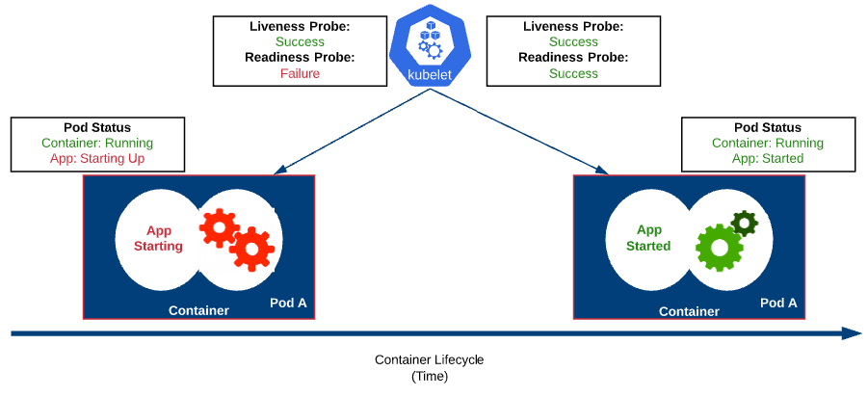
Hands On – Demonstrate Self-healing

I. Demonstrate Self-healing
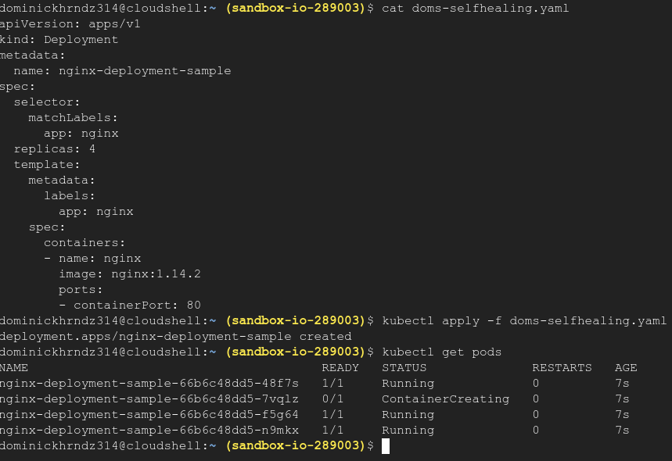
Start by deploying 4 nginx pods, apply the deployment, and then verify.
Now, delete a pod from the list and verify the new pod has a different name than the one you just deleted.
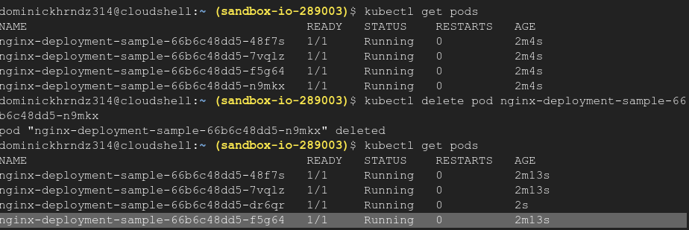
The change will happen quickly so as long as you can see a new nginx-deployment name, you have completed this training.

